Set Operations
# Source: AI Source: Provided by: [Data Path: Persons Table -> ID Column: 1, Name_En Column: Motasem Essam] -> From: [ChatGPT] on [7/7/2026]
Set operations involve creating new sets from existing sets using specific rules. Here are the primary set operations:

1-Operations Types

1. Union
# Source: AI Source: Provided by: [Data Path: Persons Table -> ID Column: 1, Name_En Column: Motasem Essam] -> From: [ChatGPT] on [7/7/2026]
- Definition: The union of two sets A and B is the set containing all elements that are in either A, B, or both.
- Notation: A∪B
- Example: If A={1,2} and B={2,3} then A∪B={1,2,3}.
- Set-builder notation: A∪B={x∣x∈A or x∈B} This means: x belongs to A∪B if x is in A, or x is in B, or both.
- Properties of Union:
  - Commutative: A∪B=B∪A
  - Associative: (A∪B)∪C=A∪(B∪C)
  - Identity: A∪∅=A
  - Idempotent: A∪A=A
  - Universal Set: If U is the universal set, A∪U=U

2. Intersection
# Source: AI Source: Provided by: [Data Path: Persons Table -> ID Column: 1, Name_En Column: Motasem Essam] -> From: [ChatGPT] on [7/7/2026]
- Definition: The intersection of two sets A and B is the set containing all elements that are in both A and B.
- Notation: A∩B
- Example: If A={1,2} and B={2,3}, then A∩B={2}.
- Set-builder notation: A∩B={x∣x∈A and x∈B} This means: x∈A and x∈B ensures that only elements present in both A and B are included in the intersection.
- Properties of Intersection:
  - Commutative: A∩B=B∩A
  - Associative: (A∩B)∩C=A∩(B∩C)
  - Identity: A∩U=A, where U is the universal set.
  - Null Set: A∩∅=∅
  - Idempotent: A∩A=A

3. Complement
# Source: AI Source: Provided by: [Data Path: Persons Table -> ID Column: 1, Name_En Column: Motasem Essam] -> From: [ChatGPT] on [7/7/2026]
- Definition: The complement of set A contains all elements in the universal set U that are not in A.
- Notation: A′ or Ā.
- Example: If U={1,2,3,4,5} and A={1,2}, then A′={3,4,5}.
- Set-builder notation: A′={x∣x∈U and x∉A} This means: x∈U: Ensures x is part of the universal set and x∉A: Ensures x is not part of the set A.
- Properties of Complement:
  - Double Complement: (A′)′=A
  - Intersection with Complement: A∩A′=∅ (no element can belong to both A and A′).
  - Union with Complement: A∪A′=U (every element in the universal set is either in A or in A′).

4. Difference
# Source: AI Source: Provided by: [Data Path: Persons Table -> ID Column: 1, Name_En Column: Motasem Essam] -> From: [ChatGPT] on [7/7/2026]
- Definition: The difference between sets A and B contains all elements that are in A but not in B.
- Notation: A−B or A∖B.
- Example: If A={1,2,3} and B={2,3,4}, then A−B={1}.
- Set-builder notation: A−B={x∣x∈A and x∉B} This means: x∉A ensures that x is excluded from set A.
- Properties of Difference:
  - A−B≠B−A (set difference is not commutative).
  - A−∅=A (removing no elements leaves A unchanged).
  - A−A=∅ (removing all elements in A results in the empty set).
  - A−U=∅, where U is the universal set.

5. Symmetric Difference
# Source: AI Source: Provided by: [Data Path: Persons Table -> ID Column: 1, Name_En Column: Motasem Essam] -> From: [ChatGPT] on [7/7/2026]
- Definition: The symmetric difference of sets A and B contains all elements that are in either of the sets but not in their intersection.
- Notation: AΔB.
- Example: If A={1,2,3} and B={2,3,4}, then AΔB={1,4}.
- Set-builder notation: AΔB={x∣(x∈A and x∉B) or (x∈B and x∉A)} or
AΔB={x∣x∈(A∪B) and x∉(A∩B)} This means: The symmetric
difference includes elements that are in A but not in B, or in B but not in A.
- Properties of Symmetric Difference:
  - Commutative: AΔB=BΔA
  - Associative: (AΔB)ΔC=AΔ(BΔC)
  - Identity: AΔ∅=A
  - Idempotent: AΔA=∅

6. Cartesian Product
# Source: AI Source: Provided by: [Data Path: Persons Table -> ID Column: 1, Name_En Column: Motasem Essam] -> From: [ChatGPT] on [7/7/2026]
- Definition: The Cartesian product is a mathematical operation that returns a set of ordered pairs from two sets, where A and B are two sets. The Cartesian product of sets A and B is the set consists of all possible ordered pairs (a,b) where the first element a is from A and the second element b is from B.
- Notation: A×B,
- Example: if A={1,2} and B={x,y} then A×B={(1,x),(1,y),(2,x),(2,y)}
- Set-builder notation: A×B={(a,b)∣a∈A and b∈B}
- Properties of Cartesian Product:
  - Non-Commutative:
A×B≠B×A unless A=B.
  - Cardinality:
∣A×B∣=∣A∣⋅∣B∣|.
  - Associativity:
(A×B)×C≠A×(B×C) as the elements form tuples of different structures.
  - Distributive Over Union:
A×(B∪C)=(A×B)∪(A×C).
  - Distributive Over Intersection:
A×(B∩C)=(A×B)∩(A×C)
  - Cartesian Product with Empty Set:
A×∅=∅.
  - Cartesian Product with Singleton:
A×{b}={(a,b)∣a∈A}

The Cartesian product is a way to combine elements from two or more sets into ordered pairs (or tuples) that represent all possible combinations. It's a fundamental concept in set theory and is used in many areas of mathematics, including relations, functions, and coordinate systems.

Tuple

Definition
# Source: AI Source: Provided by: [Data Path: Persons Table -> ID Column: 1, Name_En Column: Motasem Essam] -> From: [ChatGPT] on [7/7/2026]
A tuple is a mathematical concept used to represent an ordered collection of elements. In essence, it is an ordered list or sequence of items, where the order of the elements matters. Tuples are commonly used in various branches of mathematics, computer science, and other fields to represent relationships between objects.
Here’s a more detailed explanation:

Key Features of Tuples
# Source: AI Source: Provided by: [Data Path: Persons Table -> ID Column: 1, Name_En Column: Motasem Essam] -> From: [ChatGPT] on [7/7/2026]
1-Order matters: The arrangement of elements in a tuple is significant. That is,
(a,b) is different from (b,a), unlike sets where order
does not matter.
2-Fixed number of elements: A tuple contains a specific number of elements. A tuple with two elements is called a pair (or 2-tuple), with three elements is a triple (or 3-tuple), and so on.
3-Homogeneous or heterogeneous: The elements in a tuple can either be of the same type (homogeneous) or of different types (heterogeneous). For example:
- A 2-tuple could be (3,5)(3, 5)(3,5) (both integers).
- A 3-tuple could be ("Alice",25,5.6) (a string, an integer, and a float).

Notation
# Source: AI Source: Provided by: [Data Path: Persons Table -> ID Column: 1, Name_En Column: Motasem Essam] -> From: [ChatGPT] on [7/7/2026]
- A 2-tuple: (x,y) where x and y are elements.
- A 3-tuple: (a,b,c) where a, b, and c are elements.
- A n-tuple: An ordered list of n elements, typically written as (a₁,a₂,…,a_{n}).

Tuples Names
# Source: AI Source: Provided by: [Data Path: Persons Table -> ID Column: 1, Name_En Column: Motasem Essam] -> From: [ChatGPT] on [7/7/2026]
A 1-tuple is commonly called a single, while a 2-tuple is referred to as a double. Beyond these, the names continue as follows: a 3-tuple is a triple, a 4-tuple is a quadruple, a 5-tuple is a quintuple, a 6-tuple is a sextuple, a 7-tuple is a septuple, and so on. The general form for naming these tuples involves adding the suffix "-tuple" to the appropriate numerical prefix.
While the names of tuples are straightforward up to a certain number, they become less commonly used and more complex for higher numbers. For instance, an 8-tuple is an octuple, a 9-tuple is a nonuple, and a 10-tuple is a decuple. Beyond these, terms are rarely used in practice, and the notation "n-tuple" is preferred, where n is the number of elements.
Here are some words for tuple names.

1-tuple: Scalar or single element.
2-tuple: Pair.
3-tuple: Triple.
4-tuple: Quadruple.
5-tuple: Quintuple.
6-tuple: Sextuple, and so on.

Names for tuples of specific lengths
Tuple length, | Name | Alternative names
0 | empty tuple | null tuple / empty sequence / unit
1 | single | tuple/solo
2 | double | duo
3 | triple | trio
4 | quadruple | quad / tetrad / quartet
5 | quintuple | pentuple
6 | sextuple | hextuple / hexad / half dozen
7 | septuple
8 | octuple | octa / octet / octad / octo
9 | nonuple | nuleip
10 | decuple | deka / cent
11 | undecuple | hendecuple / hendecad
12 | duodecuple | Dozen / dodeca
13 | tredecuple | Baker's dozen
14 | quattuordecuple | double septuple
15 | quindecuple | triple quintuple
16 | sexdecuple | quadruple quadruple
17 | septendecuple
18 | octodecuple | double nonuple
19 | novemdecuple
20 | vigintuple | quadruple quintuple
30 | trigintuple
40 | quadragintuple
50 | quinquagintuple
60 | sexagintuple
70 | septuagintuple
80 | octogintuple
90 | nonagintuple
100 | centuple
200 | ducentuple
300 | trecentuple
400 | quadringentuple
500 | quingentuple
600 | sescentuple
700 | septingentuple
800 | octingentuple
900 | nongentuple
1000 | milluple | chiliad
2000 | Bimilluple
10000 | Decamilluple
1,000,000 | Micruple
1,000,000,000 | Nanuple
10^12 | Picuple
10^15 | Femtuple
10^18 | Attuple
10^21 | Zeptuple
10^24 | Yoctuple
10^27 | Rontuple
10^30 | Quectuple
10^33 | Bundectuple
10^36 | Biduple
10^39 | Triduple
10^42 | Quadiduple
10^45 | Quintiduple
10^48 | Sextiduple
10^51 | Septiduple
10^54 | Octiduple
10^57 | Noniduple
10^60 | Voguple

Usage in Different Fields
# Source: AI Source: Provided by: [Data Path: Persons Table -> ID Column: 1, Name_En Column: Motasem Essam] -> From: [ChatGPT] on [7/7/2026]
- Set Theory: Tuples are used to describe relations and functions. For example, a function from set A to set B can be described by a set of ordered pairs (tuples), such as {(a,b)∣a∈A,b∈B}.
- Computer Science: Tuples are widely used in databases and programming languages.
  - In databases, a tuple represents a single record in a table.
  - In programming, a tuple can be used to return multiple values from a function, and some languages (like Python) use tuples as built-in data structures.
- Coordinate Geometry: Tuples represent coordinates in multidimensional spaces, such as (x,y) in 2D or (x,y,z) in 3D.
- Vector Spaces: In linear algebra, tuples represent vectors, and these vectors can be used in operations like addition and scalar multiplication.

Example
# Source: AI Source: Provided by: [Data Path: Persons Table -> ID Column: 1, Name_En Column: Motasem Essam] -> From: [ChatGPT] on [7/7/2026]
- 2-tuple (ordered pair): (1,2) – This can represent a point in 2D space, or a relation between 1 and 2.
- 3-tuple: ("John",28,"Engineer") – This can represent a person with their name, age, and occupation.
- 4-tuple: (1,2,3,4) – This might represent four coordinates, or four values associated with something.

Special Cases
# Source: AI Source: Provided by: [Data Path: Persons Table -> ID Column: 1, Name_En Column: Motasem Essam] -> From: [ChatGPT] on [7/7/2026]
- A 1-tuple is just a single element in parentheses: (a). It’s sometimes written just as a to avoid confusion.
- An empty tuple contains no elements, denoted by ().

Ordered pairs
# Source: AI Source: Provided by: [Data Path: Persons Table -> ID Column: 1, Name_En Column: Motasem Essam] -> From: [ChatGPT] on [7/7/2026]
An ordered pair is a pair of elements where the order in which the elements appear matters. It is written as (a,b) where a is the first element and b is the second element. The key feature of an ordered pair is that swapping the positions of the elements results in a different pair. This is different from an unordered pair, where the order of elements doesn't matter.

An ordered pair is a fundamental concept in mathematics where the order of the elements in the pair is significant. The pair (a,b) is distinct from (b,a), and this distinction is important when working with Cartesian products, coordinate systems, and relations.

Formal Definition
# Source: AI Source: Provided by: [Data Path: Persons Table -> ID Column: 1, Name_En Column: Motasem Essam] -> From: [ChatGPT] on [7/7/2026]
An ordered pair (a,b) consists of two elements, a and b, where:
- a is the first element of the pair.
- b is the second element of the pair.

Important Characteristics of Ordered Pairs
# Source: AI Source: Provided by: [Data Path: Persons Table -> ID Column: 1, Name_En Column: Motasem Essam] -> From: [ChatGPT] on [7/7/2026]
1-Order Matters:
- (a,b) is not the same as (b,a), unless a=b.
- For example, (1,2) is different from (2,1), even though the elements are the same, just in a different order.
2- Not Commutative:
The order of elements in an ordered pair matters, so the pair (a,b) is different from (b,a)
unless a=b.
3-Equality:
Two ordered pairs are equal if and only if their corresponding elements are equal. That is:
(a,b)=(c,d)if and only ifa=c and b=d
- For example, (3,5)=(3,5), but (3,5)≠(5,3).

Example of Ordered Pairs
# Source: AI Source: Provided by: [Data Path: Persons Table -> ID Column: 1, Name_En Column: Motasem Essam] -> From: [ChatGPT] on [7/7/2026]
1-Simple Example:
- The ordered pair (1,2) means that the first element is 1, and the second element is 2.
- If we change the order, the ordered pair (2,1) means that the first element is 2, and the second element is 1, which is different from (1,2).

2-Example in Cartesian Product:
- Suppose we have two sets: A={1,2} and B={a,b}.
- The ordered pairs formed by the Cartesian product A×B would be: (1,a),(1,b),(2,a),(2,b) These ordered pairs represent all possible combinations where the first element comes from set A and the second element comes from set B.
3-Example in Relations:
- A relation on a set A can be represented by a collection of ordered pairs. For example, if A={1,2,3}, a relation R on A might be:
R={(1,2),(2,3),(3,1)}
Here, the ordered pairs indicate that 1 is related to 2, 2 is related to 3, and 3
is related to 1.

Uses of Ordered Pairs
# Source: AI Source: Provided by: [Data Path: Persons Table -> ID Column: 1, Name_En Column: Motasem Essam] -> From: [ChatGPT] on [7/7/2026]
- Coordinate Systems: In geometry, an ordered pair represents a point in a two-dimensional space. For example, (3,4) represents a point located at 3 units along the x-axis and 4 units along the y-axis.
- Functions: An ordered pair is often used to describe functions. For example, a function f that maps x to y can be represented by an ordered pair (x,y).
- Relations: As discussed, ordered pairs are used to represent relations between elements of one or more sets.

In Summary
# Source: AI Source: Provided by: [Data Path: Persons Table -> ID Column: 1, Name_En Column: Motasem Essam] -> From: [ChatGPT] on [7/7/2026]
- A tuple is an ordered collection of elements, where order matters and the elements can be of different types.
- Tuples are used in many areas, including set theory, computer science, coordinate geometry, and more.

Cartesian Product of between Two Sets
# Source: AI Source: Provided by: [Data Path: Persons Table -> ID Column: 1, Name_En Column: Motasem Essam] -> From: [ChatGPT] on [7/7/2026]
- Notation: A×B
- Formal Definition: If A and B are two sets, the Cartesian product A×B is defined as:
A×B={(a,b)∣a∈A,b∈B}
This means that each element of A is paired with every element of B,
creating an ordered pair where the first element comes from A and the second element comes from B.
- Example: If A={1,2} and B={x,y}, then A×B={(1,x),(1,y),(2,x),(2,y)}.
- Another Example
Let’s take two sets:
- A={1,2}
- B={a,b}
The Cartesian product A×B is the set of all ordered pairs where the first element
is from A and the second is from B:
A×B={(1,a),(1,b),(2,a),(2,b)}
This means:
- 1 from A is paired with a and b from B,
- 2 from A is paired with a and b from B.
Thus, the Cartesian product of A and B is:
A×B={(1,a),(1,b),(2,a),(2,b)}

Cartesian Product: Properties
# Source: AI Source: Provided by: [Data Path: Persons Table -> ID Column: 1, Name_En Column: Motasem Essam] -> From: [ChatGPT] on [7/7/2026]
1-Order Matters: The Cartesian product A×B is not the same as B×A, unless A=B. The order of the elements in the pairs matters.

For example, with A={1,2} and B={a,b}
A×B={(1,a),(1,b),(2,a),(2,b)}
B×A={(a,1),(a,2),(b,1),(b,2)}

2-Number of Pairs: If A contains m elements and B contains n elements, then
the Cartesian product A×B will contain m×n pairs (ordered
tuples).

For example,
Let A={1,2,3} and B={x,y}. The Cartesian product A×B will be:
A×B={(1,x),(1,y),(2,x),(2,y),(3,x),(3,y)}
Here, we get 6 pairs because there are 3 elements in A and 2 elements in B,
so 3×2=6 pairs.

Cartesian Product of More Than Two Sets
# Source: AI Source: Provided by: [Data Path: Persons Table -> ID Column: 1, Name_En Column: Motasem Essam] -> From: [ChatGPT] on [7/7/2026]
You can also take the Cartesian product of more than two sets. For example, if A, B, and C are three sets, the Cartesian product A×B×C is the set of all ordered triples (a,b,c), where a∈A, b∈B, and c∈C.
If:
- A={1,2}
- B={a,b}
- C={x,y}
then the Cartesian product A×B×C is:
A×B×C={(1,a,x),(1,a,y),(1,b,x),(1,b,y),(2,a,x),(2,a,y),(2,b,x),(2,b,y)}

Cartesian Product of a Set with Itself
# Source: AI Source: Provided by: [Data Path: Persons Table -> ID Column: 1, Name_En Column: Motasem Essam] -> From: [ChatGPT] on [7/7/2026]
The Cartesian product of a set with itself is simply the set of ordered pairs (or tuples) of elements from the same set. For example:
- A={1,2},
- A×A={(1,1),(1,2),(2,1),(2,2)}.

Cartesian Product in the Context of Relations
# Source: AI Source: Provided by: [Data Path: Persons Table -> ID Column: 1, Name_En Column: Motasem Essam] -> From: [ChatGPT] on [7/7/2026]
In the context of relations, the Cartesian product of two sets A and B helps form a relation between the elements of the sets. A relation is simply a subset of the Cartesian product, meaning that a relation defines which pairs of elements from A and B are considered "related."

Cartesian Product Visualization
# Source: AI Source: Provided by: [Data Path: Persons Table -> ID Column: 1, Name_En Column: Motasem Essam] -> From: [ChatGPT] on [7/7/2026]
You can think of the Cartesian product as creating a grid:
- Each element of set A corresponds to a row.
- Each element of set B corresponds to a column.
- The pairs (a,b) form the cells of this grid.
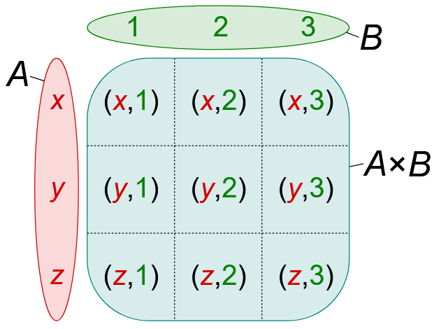

You can think of the Cartesian product as creating a grid or matrix:
- Each element of A corresponds to a row.
- Each element of B corresponds to a column.
- The ordered pairs (a,b) represent the cells in this grid.
For example, with A={1,2}A and B={a,b}, the grid looks like:
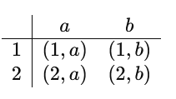

Cartesian Product applications
# Source: AI Source: Provided by: [Data Path: Persons Table -> ID Column: 1, Name_En Column: Motasem Essam] -> From: [ChatGPT] on [7/7/2026]
The Cartesian product has numerous applications in various branches of mathematics, computer science, logic, and other fields. It is a fundamental concept that helps in forming structured relationships between elements of sets and is widely used in both theoretical and practical scenarios. Here are some common uses of the Cartesian product:

1. Defining Relations
# Source: AI Source: Provided by: [Data Path: Persons Table -> ID Column: 1, Name_En Column: Motasem Essam] -> From: [ChatGPT] on [7/7/2026]
A relation between two sets A and B is a subset of their Cartesian product A×B. This allows us to describe how elements of one set are related to elements of another set.
- Example: Let A={1,2} and B={x,y}. A relation R on A×B could be R={(1,x),(2,y)}, meaning that element 1 is related to x, and element 2 is related to y.

2. Defining Functions
# Source: AI Source: Provided by: [Data Path: Persons Table -> ID Column: 1, Name_En Column: Motasem Essam] -> From: [ChatGPT] on [7/7/2026]
A function from set A to set B can be viewed as a special kind of relation where each element of A is related to exactly one element in B. The function is represented as a subset of the Cartesian product A×B.
- Example: If A={1,2} and B={a,b,c}, a function f:A→Bf could be represented as the ordered pairs f={(1,a),(2,b)}, meaning f(1)=a and f(2)=b.

3. Coordinate Systems
# Source: AI Source: Provided by: [Data Path: Persons Table -> ID Column: 1, Name_En Column: Motasem Essam] -> From: [ChatGPT] on [7/7/2026]
In geometry, the Cartesian product is used to define coordinate systems, such as the 2D Cartesian plane or 3D space, where each point is represented as an ordered pair or tuple of numbers.
- 2D Coordinates: For a 2D plane, points are represented as ordered pairs (x,y), where x and y are real numbers.
- 3D Coordinates: In 3D space, points are represented as ordered triples (x,y,z).

4. Database Design (Relational Databases)
# Source: AI Source: Provided by: [Data Path: Persons Table -> ID Column: 1, Name_En Column: Motasem Essam] -> From: [ChatGPT] on [7/7/2026]
In database theory, the Cartesian product is used in relational databases to combine data from two or more tables. When performing a JOIN operation in a relational database, the Cartesian product of the tables is computed, followed by filtering based on a specific condition.
- Example: If table A has columns {a1,a2} and table B has columns {b1,b2}, the Cartesian product A×B gives all combinations of rows from both tables. For instance, if table A has 3 rows and table B has 2 rows, the Cartesian product will result in 6 rows.

5. Combinatorics (Counting)
# Source: AI Source: Provided by: [Data Path: Persons Table -> ID Column: 1, Name_En Column: Motasem Essam] -> From: [ChatGPT] on [7/7/2026]
The Cartesian product is used in combinatorics to count the number of possible combinations that can be formed from elements of different sets.
- Example: If you want to select one item from set A={a,b} and one item from set B={x,y,z}, the total number of combinations is the size of A×B, which is 2×3=6.

6. Graph Theory
# Source: AI Source: Provided by: [Data Path: Persons Table -> ID Column: 1, Name_En Column: Motasem Essam] -> From: [ChatGPT] on [7/7/2026]
In graph theory, the Cartesian product of two graphs is a type of graph product where the vertices of the product graph are ordered pairs of vertices from the original graphs, and the edges are defined based on the edges of the original graphs.
- Example: If G1​ and G2​ are two graphs, the Cartesian product G1×G2 will have vertex pairs (v1,v2) where v1​ is from G1​ and v2​ is from G2​. There will be an edge between (v1,v2) and (v1′,v2′) if and only if either v1​ is adjacent to v1′ in G1​, or v2​ is adjacent to v2′ in G2​.

7. Product Spaces in Topology
# Source: AI Source: Provided by: [Data Path: Persons Table -> ID Column: 1, Name_En Column: Motasem Essam] -> From: [ChatGPT] on [7/7/2026]
In topology, the Cartesian product of topological spaces is used to define product spaces. The Cartesian product of two spaces X and Y is itself a space, and the topology on the product space is generated by the product of the topologies on X and Y.
- Example: If X and Y are topological spaces, the product space X×Y consists of all ordered pairs (x,y), where x∈X and y∈Y, with the product topology.

8. Probability Theory
# Source: AI Source: Provided by: [Data Path: Persons Table -> ID Column: 1, Name_En Column: Motasem Essam] -> From: [ChatGPT] on [7/7/2026]
In probability theory, the Cartesian product is used to model sample spaces. The sample space of an experiment involving multiple independent events is the Cartesian product of the sample spaces of the individual events.
- Example: If you flip two coins, the sample space S is the Cartesian product of the sample spaces of the individual coin flips, which is {H,T}×{H,T}={(H,H),(H,T),(T,H),(T,T)}.

9. Computer Science: Data Structures
# Source: AI Source: Provided by: [Data Path: Persons Table -> ID Column: 1, Name_En Column: Motasem Essam] -> From: [ChatGPT] on [7/7/2026]
In computer science, the Cartesian product is used to define combinations of data in certain algorithms, such as in the generation of permutations and combinations. It is also used to represent multi-dimensional arrays and matrices.
- Example: If you want to create a 2D matrix of size m×n, you can think of it as the Cartesian product {1,2,…,m}×{1,2,…,n}, where each ordered pair (i,j) represents the position of an element in the matrix.

10. Game Theory and Decision Making
# Source: AI Source: Provided by: [Data Path: Persons Table -> ID Column: 1, Name_En Column: Motasem Essam] -> From: [ChatGPT] on [7/7/2026]
In game theory, the Cartesian product is used to model the set of possible strategies or moves available to players in a game. Each strategy can be represented as an ordered pair or tuple of actions taken by the players.
- Example: In a two-player game where Player 1 has 3 choices and Player 2 has 2 choices, the set of all possible strategy combinations is {1,2,3}×{A,B}, which results in 6 possible combinations.

Cartesian Product and Its Utility
# Source: AI Source: Provided by: [Data Path: Persons Table -> ID Column: 1, Name_En Column: Motasem Essam] -> From: [ChatGPT] on [7/7/2026]
The Cartesian product is used in many fields because it provides a systematic and structured way to represent and analyze relationships between elements from multiple sets.

The utility of the Cartesian product arises from its ability to generate all possible combinations of elements, which is essential for modeling, reasoning, and solving problems in various disciplines. Here's why it's useful in each of the fields mentioned:

7. Partition of a Set
# Source: AI Source: Provided by: [Data Path: Persons Table -> ID Column: 1, Name_En Column: Motasem Essam] -> From: [ChatGPT] on [7/7/2026]
Definition: A partition of a set A is a collection of non-empty subsets of A such that every element of A is included in exactly one of these subsets. In other words, the subsets are mutually exclusive and collectively exhaustive.

Or
The partition of a set is a way of dividing the set into disjoint subsets such that every element of the original set belongs to exactly one of these subsets. In other words, a partition of a set S is a collection of non-empty subsets of S that satisfy two main conditions:
- Union condition: The union of all subsets in the partition must equal the original set SSS. That is, every element of S is included in one of the subsets.
S=A1∪A2∪⋯∪
- Disjointness condition: No two subsets in the partition can have any common elements. In other words, the subsets are pairwise disjoint.
Ai∩Aj=∅ fori≠j

- Example: If A={1,2,3,4}, a possible partition is {{1,2},{3},{4}}.Here, the subsets {1,2}, {3}, and {4} are disjoint and their union is the original set A.
- Another Example:
Consider the set S={1,2,3}
A possible partition of SSS could be:
{{1},{2,3}}
Here, the subsets are {1} and {2,3}, and:
- The union of these subsets is {1}∪{2,3}={1,2,3}, which is the original set.
- The subsets are disjoint because {1}∩{2,3}=∅

Key Points
# Source: AI Source: Provided by: [Data Path: Persons Table -> ID Column: 1, Name_En Column: Motasem Essam] -> From: [ChatGPT] on [7/7/2026]
- A partition does not require all subsets to have the same size.
- The subsets in the partition must be non-empty.
- Every element of the original set must appear in exactly one of the subsets.

Special Case
# Source: AI Source: Provided by: [Data Path: Persons Table -> ID Column: 1, Name_En Column: Motasem Essam] -> From: [ChatGPT] on [7/7/2026]
The trivial partition of any set S is the set itself as a single subset, and the discrete partition is where each element of the set is its own subset.
For example, for S={a,b,c}, its partitions could include:
- {{a,b,c}} (trivial partition),
- {{a},{b,c}},
- {{a},{b},{c}}(discrete partition).

Extract partitions from set
# Source: AI Source: Provided by: [Data Path: Persons Table -> ID Column: 1, Name_En Column: Motasem Essam] -> From: [ChatGPT] on [7/7/2026]
Extracting partitions from a set means generating all possible ways to divide the set into non-empty, disjoint subsets. This process involves finding all possible collections of subsets that satisfy the conditions for a partition: the union of the subsets is the original set, and the subsets are pairwise disjoint.
To extract partitions from a set, we can use different approaches, and here's a basic outline of how to do this manually

1-Manually Generating Partitions
# Source: AI Source: Provided by: [Data Path: Persons Table -> ID Column: 1, Name_En Column: Motasem Essam] -> From: [ChatGPT] on [7/7/2026]
For a small set, you can manually list all partitions. Let's use an example to illustrate.
Example: Extracting partitions of the set S={1,2,3}
- Step 1: Start by considering all subsets of S. For the set S={1,2,3}, the possible subsets are:
The subsets of S={1,2,3} are:
{∅,{1},{2},{3},{1,2},{1,3},{2,3},{1,2,3}}
- {1},{2},{3}
- {1,2},{3}
- {1,3},{2}
- {2,3},{1}
- {1,2,3} (this is one subset containing all elements)

- Step 2: Ensure all subsets in each partition are disjoint and their union is the original set.
Thus, the partitions of S={1,2,3} are:
{{1,2,3}},{{1},{2,3}},{{1,3},{2}},{{1},{2},{3}}

2-Mathematical Approach (Set Partitions and Bell Numbers)
# Source: AI Source: Provided by: [Data Path: Persons Table -> ID Column: 1, Name_En Column: Motasem Essam] -> From: [ChatGPT] on [7/7/2026]
In mathematics, the number of partitions of a set of n elements is given by the Bell number, B_{n}. There are several ways to compute the Bell numbers and generate the partitions, such as:
- Stirling numbers of the second kind: These give the number of ways to partition a set into a specific number of non-empty subsets.

In mathematics, Bell numbers and Stirling numbers of the second kind are key concepts for understanding how to partition a set. Let’s break down both methods with examples.

1. Bell Numbers
# Source: AI Source: Provided by: [Data Path: Persons Table -> ID Column: 1, Name_En Column: Motasem Essam] -> From: [ChatGPT] on [7/7/2026]
The Bell number B_{n} represents the number of partitions of a set with n elements. The Bell number can be calculated using various methods, including recursive formulas.

Recursive Formula for Bell Numbers:
Bell numbers can be calculated using the following recurrence relation:
B_{0​}=1
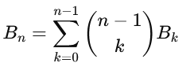

Example:
Let’s calculate the first few Bell numbers:
- B₀=1(base case: 1 way to partition the empty set)
- B₁=1(there is only 1 way to partition the set {1})
- B₂=2 (the set {1,2} can be partitioned as {{1,2}} and {{1},{2}})
- B₃=5 (the set {1,2,3} can be partitioned in 5 ways, detailed below)

Partitions of S={1,2,3}
The Bell number B₃ tells us there are 5 distinct partitions of the set {1,2,3}. Here are all the partitions of S={1,2,3}:
- {{1,2,3}} (all elements together in one subset)
- {{1},{2,3}}
- {{2},{1,3}}
- {{3},{1,2}}
- {{1},{2},{3}} (each element is its own subset)

2. Stirling Numbers of the Second Kind
# Source: AI Source: Provided by: [Data Path: Persons Table -> ID Column: 1, Name_En Column: Motasem Essam] -> From: [ChatGPT] on [7/7/2026]
The Stirling numbers of the second kind, denoted S(n,k), represent the number of ways to partition a set of n elements into exactly k non-empty subsets.
Stirling Number Formula:
The Stirling number S(n,k) can be calculated recursively as follows:
S(n,k)=k⋅S(n−1,k)+S(n−1,k−1)
Where:
- S(n−1,k) is the number of ways to partition n−1 elements into k subsets.
- S(n−1,k−1) is the number of ways to partition n−1 elements into k−1 subsets, and then add the n^{th} element as a new subset.

Example: Stirling Numbers for n=3:
Let’s compute the Stirling numbers for n=3 and k=1,2,3:
- S(3,1): The number of ways to partition 3 elements into 1 subset. This is just 1, because all 3 elements must be in the same subset.
  - S(3,1)=1
- S(3,2): The number of ways to partition 3 elements into 2 subsets. This is 3, because we can partition {1,2,3} into two subsets in 3 ways:
  - {{1},{2,3}},{{2},{1,3}},{{3},{1,2}}
  - S(3,2)=3
- S(3,3) The number of ways to partition 3 elements into 3 subsets. This is 1, because each element must be in its own subset.
  - S(3,3)=1

Summarizing Bell Number and Stirling Numbers
# Source: AI Source: Provided by: [Data Path: Persons Table -> ID Column: 1, Name_En Column: Motasem Essam] -> From: [ChatGPT] on [7/7/2026]
For a set S={1,2,3}:
- The Bell number B₃=5, which corresponds to the 5 possible partitions listed earlier.
- The Stirling numbers are:
  - S(3,1)=1 (1 subset),
  - S(3,2)=3 (2 subsets),
  - S(3,3)=1 (3 subsets).

Conclusion
# Source: AI Source: Provided by: [Data Path: Persons Table -> ID Column: 1, Name_En Column: Motasem Essam] -> From: [ChatGPT] on [7/7/2026]
- Bell Numbers count the total number of partitions for a set of n elements.
- Stirling Numbers give the number of ways to partition a set into exactly k subsets.

2-General Set Operations Properties
# Source: AI Source: Provided by: [Data Path: Persons Table -> ID Column: 1, Name_En Column: Motasem Essam] -> From: [ChatGPT] on [7/7/2026]
- Associative Property:
  - Union: (A∪B)∪C=A∪(B∪C)
  - Intersection: (A∩B)∩C=A∩(B∩C)
- Commutative Property:
  - Union: A∪B=B∪A
  - Intersection: A∩B=B∩A
- Distributive Property:
  - Union over Intersection: A∪(B∩C)=(A∪B)∩(A∪C)
  - Intersection over Union: A∩(B∪C)=(A∩B)∪(A∩C)
- Idempotent Law:
  - Intersection: A ⋂ A = A
  - Union: A ∪ A = A
- Identity Laws
  - Union Identity: A∪∅=A
  - Intersection Identity: A∩U=A
- Domination (Null) Laws
  - Intersection with Empty Set: A∩∅=∅
  - Union with Universal Set: A∪U=U
- De Morgan's Laws:
  - (A∪B)′=A′∩B′
  - (A∩B)′=A′∪B′
- Complement Laws
  - Union with Complement: A∪A′=U
  - Intersection with Complement: A∩A′=∅
  - Complement of Universal Set: U′=∅
  - Complement of Empty Set: ∅′=U
  - Double Complement Law: (A′)′=A

3. Set Formulas
# Source: AI Source: Provided by: [Data Path: Persons Table -> ID Column: 1, Name_En Column: Motasem Essam] -> From: [ChatGPT] on [7/7/2026]
Set formulas are mathematical expressions used to describe the relationships and operations between sets. These formulas help in understanding how sets interact with each other and how to perform various operations on sets. Here are some common set formulas and their meanings:

1. Cardinality of a Set
# Source: AI Source: Provided by: [Data Path: Persons Table -> ID Column: 1, Name_En Column: Motasem Essam] -> From: [ChatGPT] on [7/7/2026]
- Definition: The cardinality of a set A, denoted as ∣A∣, is the number of elements in the set A.
- Example: If A={1,2,3,4}, then the cardinality of A is ∣A∣=4 Or n (A) = 4.
The Cardinal number, cardinality, or order of a set indicates the total number of elements in the set. For natural even numbers less than 10, n(A) = 4. A set is defined as a unique collection of elements. One of the important conditions for defining a set is that all elements of the set must have common properties.
eg. A = { 2, 4, 6, 8 } , cardinality of set A is 4.

- A finite set has finite order (or cardinality). An infinite set has infinite order (or cardinality).
- For finite sets the order (or cardinality) is the number of elements.

2. Cardinality of a Set Formulas
# Source: AI Source: Provided by: [Data Path: Persons Table -> ID Column: 1, Name_En Column: Motasem Essam] -> From: [ChatGPT] on [7/7/2026]
- n(AUB) = n(A) + n(B) - n (A⋂B)
- n(AUB) = n(A-B) + n(A⋂B) + n(B-A)
- If A ⋂ B = ∅, then n(A∪B)=n(A)+n(B)
- n(A-B) + n(A⋂B) - n(A)
- n(B-A) + n(A⋂B) - n(B)
- n(A∪B∪C) = n(A) +n(B) + n(C) - n(A⋂B) - n(B⋂C) - n(C⋂A) - n(A⋂B⋂C)
- n(U) = n(A) + n(B) + - n(A⋂B) + n((A∪B)')
- n((A∪B)') = n(U) + n(A⋂B) - n(A) - n(B)

3. Sets Formulas of Complement Sets
# Source: AI Source: Provided by: [Data Path: Persons Table -> ID Column: 1, Name_En Column: Motasem Essam] -> From: [ChatGPT] on [7/7/2026]
Set formulas for complement of a set include the basic complement law, the de morgan's laws, the double complement, and the law of empty set and universal set.
- Complement Law : A∪A' = U, A⋂A' = Ø and A' = U - A
- De Morgan's Laws: (A ∪B)' = A' ⋂B' and (A⋂B)' = A' ∪ B'
- Law of Double complementation: (A')' = A
- Laws of Empty set and Universal Set: Ø' = ∪ and ∪' = Ø

4. Sets Formulas of Difference of Sets
# Source: AI Source: Provided by: [Data Path: Persons Table -> ID Column: 1, Name_En Column: Motasem Essam] -> From: [ChatGPT] on [7/7/2026]
The set formulas or difference of sets across two sets, across a null set, and for complement of set is as follows.
- A - A = Ø
- B - A = B⋂ A'
- B - A = B - (A⋂B)
- (A - B) = A if A⋂B = Ø
- (A - B) ⋂ C = (A⋂ C) - (B⋂C)
- A ΔB = (A-B) U (B- A)
- n(AUB) = n(A - B) + n(B - A) + n(A⋂B)
- n(A - B) = n(A∪B) - n(B)
- n(A - B) = n(A) - n(A⋂B)
- n(A') = n(∪) - n(A)

5.Sets Formulas of Symmetric Difference of Sets
# Source: AI Source: Provided by: [Data Path: Persons Table -> ID Column: 1, Name_En Column: Motasem Essam] -> From: [ChatGPT] on [7/7/2026]
- AΔB = (A−B)∪(B−A)
- AΔB = (A∩B)′

6. Solved Examples Using Sets Formulas

Example 1
# Source: AI Source: Provided by: [Data Path: Persons Table -> ID Column: 1, Name_En Column: Motasem Essam] -> From: [ChatGPT] on [7/7/2026]
In a club, each person plays chess or carrom or both. The number of people who play chess, carrom or both are 11, 12 and 3 respectively. Representing this given information as sets and using the set formulae, find the people who play either chess or carrom?
Solution:
Let n(chess)= n(P) and n(chess) = n(Q)
Then we have n(either chess or carrom) = n(P∪Q) and n(chess and carrom) = n(P∩Q)
Given n(P) = 12 , n(Q) = 12 and (P∩Q) = 3
Applying the set formula, n(P∪Q) = n(P) + n(Q) - n(P∩Q) = 11 + 12 - 3 = 20
Answer: The number of people who play both chess or carrom = 20

Example 2
# Source: AI Source: Provided by: [Data Path: Persons Table -> ID Column: 1, Name_En Column: Motasem Essam] -> From: [ChatGPT] on [7/7/2026]
In a class of 70 students, 45 students like to play soccer, 52 students like to play baseball. All the students like to play at least one of the two games. Using sets formula find how many students like to play soccer or baseball ? How many students like to play only soccer?
Solution:
Given: n(A U B ) = 70, n(A) = 45, n(B) = 52
We are required to find n (A ⋂ B)
Using sets formula, n(A ⋂ B)= n(A) + n(B) - n(A ∪ B)
n(A ⋂ B)= 45 + 52 - 70 = 27
Students who like to play only Soccer = 45 - 27 =18
Answer: 18 students like to play only soccer.

Example 3
# Source: AI Source: Provided by: [Data Path: Persons Table -> ID Column: 1, Name_En Column: Motasem Essam] -> From: [ChatGPT] on [7/7/2026]
Example 3: There are 100 students, 35 like painting and 45 like dancing, and 10 like both. How many of the students like either of them or neither of them?
Solution:
Total number of students = 100
Number of students that like painting, n(P) = 35
Number of students that like dancing, n(D) = 45
Number of students who like both, n(P∩D) = 10
We are required to find n(A ∪ B) i.e., number of students who like either of them and
Using sets formula, n(P∪D) = n(P) + n(D) – n(P∩D)
⇒ 45 + 35 - 10 = 70
Number of students who like neither = Total students – n(P∪D) = 100 – 70 = 30
Answer: Therefore 70 students like either of them and 30 students like neither of them.

Example 4
# Source: AI Source: Provided by: [Data Path: Persons Table -> ID Column: 1, Name_En Column: Motasem Essam] -> From: [ChatGPT] on [7/7/2026]
Proof: AΔB=(A−B)∪(B−A)

Let A={1,2,3} and B={3,4,5}:
- A−B={1,2}
- B−A={4,5}
- (A−B)∪(B−A)={1,2}∪{4,5}={1,2,4,5}
- AΔB={1,2,4,5}
Thus, AΔB=(A−B)∪(B−A).

4-Set Operations on set types

1-Set Operations on Empty Set
# Source: AI Source: Provided by: [Data Path: Persons Table -> ID Column: 1, Name_En Column: Motasem Essam] -> From: [ChatGPT] on [7/7/2026]
- Union: A∪∅=A
- Intersection: A∩∅=∅
- Difference: A−∅=A
- Complement: ∅′=U
- Symmetric Difference: AΔ∅=A
- Cartesian Product: A×∅=∅
- Empty Set and Subset:The empty set is a subset of every set, including itself. This means that for any set A, we have:
∅⊆A This is because the empty set has no elements, and there are no elements in it to contradict the condition that every element of the empty set (of which there are none) must be an element of A.
- Empty Set and Power Set: The power set of a set A is the set of all subsets of A, including the empty set and A itself. The power set of the empty set (∅\emptyset∅) is the set that contains only the empty set:
P(∅)={∅}, So, the power set of the empty set has one element: the empty set itself.
- Empty Set and Functions: The empty set plays a role in the domain and range of functions. For example:
  - If the domain of a function is the empty set, then the function has no inputs and therefore no outputs.
  - If the range of a function is the empty set, it means the function never produces any outputs.

- partition of the empty set is the set containing just the empty set: {∅}

Properties of Set Operations on Empty Set
# Source: AI Source: Provided by: [Data Path: Persons Table -> ID Column: 1, Name_En Column: Motasem Essam] -> From: [ChatGPT] on [7/7/2026]
- Commutative:
- Union: A∪∅=∅∪A=A
- Intersection: A∩∅=∅∩A=∅
- Symmetric Difference: AΔ∅=∅ΔA=A
- Explanation:
  - The empty set does not add any new elements when unioned with a set, and no common elements are found when intersected with any set.
  - Symmetric difference with the empty set simply returns the set itself, because there are no elements in ∅\emptyset∅ to affect the result.
- Associative:
- Union: (A∪B)∪∅=A∪(B∪∅)=A∪B
- Intersection: (A∩B)∩∅=A∩(B∩∅)=∅
- Symmetric Difference: (AΔB)Δ∅=AΔ(BΔ∅)=AΔB
- Explanation:
  - The union of any set with the empty set is associative because the empty set doesn’t contribute any elements.
  - The intersection of any set with the empty set results in the empty set, and is associative.
  - Symmetric difference involving the empty set is associative, since the empty set does not affect the result.
- Distributive:
- Union Distributes Over Intersection: A∪(B∩∅)=(A∪B)∩(A∪∅)=A∪B
- Intersection Distributes Over Union: A∩(B∪∅)=(A∩B)∪(A∩∅)=A∩B
- Explanation:
  - Since B∩∅=∅, union distributes trivially.
  - For the intersection, A∩∅=∅, so the intersection distributes correctly as well.
- Idempotent:
- A∪A=A
- A∩A=A
- AΔA=∅
- Explanation:
  - The union and intersection of a set with itself return the set itself.
  - The symmetric difference of a set with itself is the empty set, as every element cancels out.
- Identity:
- Union with the Empty Set: A∪∅=A
- Intersection with the Universal Set: A∩U=A (where U is the universal set)
- Symmetric Difference with the Empty Set: AΔ∅=A
- Explanation:
  - The empty set does not affect the union, so A∪∅=A
  - The intersection of any set with the universal set is the set itself.
  - The symmetric difference of a set with the empty set is the set itself, since no elements are excluded.

2-Set Operations on Finite Sets
# Source: AI Source: Provided by: [Data Path: Persons Table -> ID Column: 1, Name_En Column: Motasem Essam] -> From: [ChatGPT] on [7/7/2026]
- Union: A∪B={x∣x∈A or x∈B}, if A={1,2} and B={2,3}, then: A∪B={1,2,3}
- Intersection: A∩B={x∣x∈A and x∈B}, if A={1,2} and B={2,3}, then: A∩B={2}
- Difference: A−B={x∣x∈A and x∉B}, If A={1,2} and B={2,3}, then: A−B={1}
- Complement: A′=U−A, If A={1,2} and U={1,2,3,4}, then: A′={3,4}
- Symmetric Difference: AΔB=(A−B)∪(B−A), If A={1,2} and B={2,3}, then: AΔB={1,3}
- Cartesian Product: A×B={(a,b)∣a∈A and b∈B} If A={1,2} and B={x,y}, then: A×B={(1,x),(1,y),(2,x),(2,y)}
- Finite Sets and Subset: A set B is a proper subset of A, denoted B⊂A, if B⊆A and B≠A. Examples:
  - If A={1,2,3} and B={1,2}, then B⊂A because B is a proper subset of A.
  - If A={1,2,3} and B={1,2,3}, then B=A, so B is not a proper subset.
  - Let’s take two finite sets A={1,2} and B={a,b}: {1}⊆A, {a}⊆B
- Finite Sets and Power Set: The power set of a set A, denoted P(A), is the set of all possible subsets of A, including the empty set and A itself.
  - Cardinality of Power Set:
If A has n elements, then the power set of A contains 2^{n} subsets.
  - Example:
    - If A={1,2}, then the power set P(A)={∅,{1},{2},{1,2}} has 4 elements, because 2²=4.
    - If A={1,2,3}, then P(A)={∅,{1},{2},{3},{1,2},{1,3},{2,3},{1,2,3}}, and it has 8 elements, because 2³=8.
    - Let’s take two finite sets A={1,2} and B={a,b}: P(A)={∅,{1},{2},{1,2}}, P(B)={∅,{a},{b},{a,b}}
- Finite Sets and Functions: A function f from set A to set B, denoted f:A→B, is a rule that assigns each element in A (called the domain) to exactly one element in B (called the codomain), If A and B are finite sets, the number of possible functions f:A→B is ∣B∣^{∣A∣}, where ∣A∣ is the number of elements in A (domain) and ∣B∣ is the number of elements in B (codomain).
  - Example:
If A={1,2} and B={a,b}, then the number of functions from A to B is 2²=4. The possible functions are:
      - f(1)=a,f(2)=a
      - f(1)=a,f(2)=b
      - f(1)=b,f(2)=a
      - f(1)=b,f(2)=b
  - Injective Function (One-to-One): A function f:A→B is injective if different elements in A map to different elements in B. That is, f(a₁)=f(a₂) implies a₁=a₂.
  - Surjective Function (Onto): A function f:A→B is surjective if every element of B has at least one element of A mapping to it. In other words, the range of the function is equal to the codomain.
  - Bijective Function: A function f:A→B is bijective if it is both injective and surjective. This means that there is a one-to-one correspondence between elements of A and elements of B.

- partition of a finite set divides the set into disjoint, non-empty subsets that cover the entire set.
  - Example:
    - For a set with 3 elements, B₃=5. The five partitions of the set {1,2,3} are:
- {{1,2,3}}
- {{1},{2,3}}
- {{2},{1,3}}
- {{3},{1,2}}
- {{1},{2},{3}}

Properties of Set Operations on Finite Sets
# Source: AI Source: Provided by: [Data Path: Persons Table -> ID Column: 1, Name_En Column: Motasem Essam] -> From: [ChatGPT] on [7/7/2026]
1-Commutative:
- Union: A∪B=B∪A
- Intersection: A∩B=B∩A
- Symmetric Difference: AΔB=BΔA
- Explanation:
  - The union operation is commutative because the order in which we combine the elements of two sets doesn't affect the result. Whether we add the elements of B to A or the elements of A to B, the result is the same.
  - The intersection operation is commutative because the order of the sets doesn’t affect which elements are shared between them. The result is the set of common elements, regardless of which set is listed first.
  - Symmetric difference is commutative because the elements that belong to either of the sets A or B, but not both, will remain the same regardless of the order of the sets.
2-Associative:
- Union: (A∪B)∪C=A∪(B∪C)
- Intersection: (A∩B)∩C=A∩(B∩C)
- Symmetric Difference: (AΔB)ΔC=AΔ(BΔC)
- Explanation:
  - The union operation is associative because the grouping of sets doesn't affect the final result. The elements in all sets are combined into one set, and the order of grouping doesn’t change the outcome.
  - The intersection operation is associative because the grouping of sets doesn't affect which elements are shared. The common elements among all the sets will be the same, regardless of how the sets are grouped.
  - Symmetric difference is associative because the elements that belong to an odd number of sets (whether one or three) do not depend on the order of operation. The result will always be the same set of elements.
3-Distributive:
- Union distributes over intersection: A∪(B∩C)=(A∪B)∩(A∪C)
- Intersection distributes over union: A∩(B∪C)=(A∩B)∪(A∩C)
- Explanation:
  - The union distributes over intersection because combining a set A with the intersection of B and C gives the same result as first unioning A with B, and A with C, then intersecting the two resulting sets. Essentially, unioning A with the "overlap" of B and C results in the same set as intersecting the unions.
  - The intersection distributes over union because the common elements of A with the union of B and C are the same as the union of the common elements between A and B, and between A and C. This property allows us to "distribute" the intersection across the union.
4-Idempotent:
- A∪A=A
- A∩A=A
- AΔA=∅
- Explanation:
  - The union of a set with itself doesn’t add any new elements, so it remains equal to the original set. This is called the idempotent property of union.The intersection of a set with itself is just the set itself because all elements in A are obviously shared with A. This is the idempotent property of intersection.
  - Explanation: The symmetric difference of a set with itself is the empty set because every element in A is canceled out by being in both sets. Therefore, no element is left.

5-Identity:
- A∪∅=A
- A∩U=A
- AΔ∅=A
- Explanation:
  - The union of a set with the empty set doesn’t add any new elements to the set. Thus, the original set A is unchanged when unioned with the empty set.
  - The intersection of any set with the universal set is the set itself, because every element in A is also in U, so no elements are excluded.
  - The symmetric difference of any set with the empty set is the set itself, because no elements are excluded or added. Essentially, the set A remains unchanged.

3-Set Operations on Infinite Sets
# Source: AI Source: Provided by: [Data Path: Persons Table -> ID Column: 1, Name_En Column: Motasem Essam] -> From: [ChatGPT] on [7/7/2026]
- Union: The union of two sets A and B, denoted A∪B, includes all elements in either A, B, or both.
  - Properties for Infinite Sets:
    - If A and B are both infinite:
      - ∣A∪B∣| depends on their cardinalities.
      - For example, N∪Z=Z (since Z already contains N).
    - If A is infinite and B is finite:
      - A∪B=A (the finite set does not change the cardinality of the infinite set).
- Intersection: The intersection of two sets A and B, denoted A∩B, includes all elements common to both A and B.
  - Properties for Infinite Sets:
    - If A∩B≠∅, it could be:
      - Infinite (e.g., N∩Z=N).
      - Finite (e.g., {1,2,3}∩N={1,2,3}).
      - Empty (e.g., N∩Q^{c}=∅ is the complement of the rationals).
- Difference: The difference of two sets A and B, denoted A−B, includes all elements in A that are not in B.
  - Properties for Infinite Sets:
    - If A is infinite and B is finite:
      - A−B remains infinite.
      - Example: N−{1,2,3}={4,5,6,… }.
    - If A and B are both infinite:
      - The result depends on their relative sizes and overlap.
      - Example: R−Q (the set of irrationals) is infinite.

- Complement: The complement of a set A, denoted A′ or A‾, includes all elements not in A, relative to a universal set U.
  - Properties for Infinite Sets:
    - If A is infinite and U is infinite:
      - A′ can also be infinite.
      - Example: (N)′ (the complement of natural numbers in Z) is Z∖N={…,−3,−2,−1}.

- Symmetric Difference: The symmetric difference of two sets A and B, denoted AΔB, includes all elements in A or B but not in both.
  - Properties for Infinite Sets:
    - If A and B are disjoint infinite sets:
      - AΔB=A∪B.
    - Example: NΔZ=Z∖N∪N (all integers that are not natural numbers).

- Cartesian Product: The Cartesian product of two sets A and B, denoted A×B, includes all ordered pairs (a,b) where a∈A and b∈B.
  - Properties for Infinite Sets:
    - If both A and B are infinite:
      - A×B is infinite.
      - Example: N×N (ordered pairs of natural numbers) has the same cardinality as N.

    - If A is infinite and B is finite:
      - A×B is infinite.
    - If both are countably infinite:
      - A×B is countably infinite.
- InfiniteSets and Subset: An infinite set A can have both finite subsets and infinite subsets:
  - Finite Subsets: For example, if A=N (natural numbers), {1,2,3}⊆N is a finite subset.
  - Infinite Subsets: If A=N, then {n∈N∣n is even}={2,4,6,… }⊆N is an infinite subset.
  - Key Properties of Infinite Sets and Subsets
    - Proper Subsets of Infinite Sets: An infinite set can have proper subsets that are:
      - Finite: Example: {1,2,3}⊂N.
      - Infinite: Example: Z⊂Q (integers are a proper infinite subset of rational numbers).
    - Countably Infinite Sets and Subsets:
      - If A is countably infinite (e.g., N), then every subset B⊆A is either finite or countably infinite.
    - Uncountably Infinite Sets and Subsets:
      - If A is uncountably infinite (e.g., R), subsets can be:
        - Countably infinite: Example, Q⊂R (rationals are a countably infinite subset of real numbers).
        - Uncountably infinite: Example, [0,1]⊂R (the interval [0,1] is an uncountably infinite subset of R.
    - Infinite Subset of Infinite Sets: Any infinite subset of an infinite set can be:
      - Equinumerous: It may have the same cardinality as the original set (e.g., Z⊆Z).
      - Smaller Cardinality: For example, N⊂R.
    - Power Set of Infinite Sets:
      - For an infinite set A, the power set P(A) always has a strictly larger cardinality than A itself:
        - If A is countably infinite (N), P(A) is uncountably infinite.
        - If A is uncountably infinite (R), P(A) has an even larger cardinality.
    - Subset Relationships Among Infinite Sets
      - Subset Chain: Infinite sets can form nested chains of subsets:
        - N⊂Z⊂Q⊂R⊂C.
      - Subset Comparisons:
        - Two infinite sets A and B can be subsets of each other and still be equinumerous.
        - Example: N⊆2 (even natural numbers) and 2N⊆N, but both are countably infinite.

- Infinite Set and Power Set: The power set of an infinite set A, denoted P(A), is the set of all subsets of A.
  - Properties:
    - If A is countably infinite:
      - P(A) is uncountably infinite (e.g., the power set of N has the same cardinality as R).
- Infinite Sets and Functions: A function f:A→B is a rule that assigns each element of A (the domain) to exactly one element in B (the codomain).
  - If A or B is an infinite set, the function's behavior can differ significantly from the finite case.
  - Key Concepts and Properties
    - 1. Injective Functions (One-to-One)
      - A function f:A→B is injective if each element of A maps to a unique element of B.
      - Infinite Set Case:
        - If A and B are both infinite, an injective function can exist even when A has the same or smaller cardinality as B.
        - Example: f(n)=2nf(n) = 2nf(n)=2n, where f:N→N, is injective but not surjective (only maps to even numbers).
    - 2. Surjective Functions (Onto)
      - A function f:A→B is surjective if every element of B has at least one preimage in A.
      - Infinite Set Case:
        - If A and B are infinite, surjectivity depends on the sizes of A and B.
        - Example: f(x)=x², where f:R→[0,∞), is surjective but not injective.
    - 3. Bijective Functions (One-to-One and Onto)
      - A function f:A→B is bijective if it is both injective and surjective.
      - Infinite Set Case:
        - A bijection implies ∣A∣=∣B∣ (the cardinalities of A and B are the same).
        - Example: f(x)=x+1, where f:Z→Z, is bijective (shifts all integers by 1).
      - Special Considerations for Infinite Sets
        - Functions with Countably Infinite Sets:
          - If A and B are countably infinite, a bijection always exists between them (e.g., N→Z via a pairing function).
          - This is a cornerstone of countable infinity: all countably infinite sets have the same cardinality.
        - Functions with Uncountably Infinite Sets:
          - If A or B is uncountably infinite (e.g., R), then a bijection might or might not exist depending on their cardinalities.
      - Important Results and Examples
        - 1. Domain and Range:
          - If the domain of a function is infinite, the function itself may map infinitely many inputs to outputs.
          - If the range of a function is infinite, the function's output values span infinitely many elements of the codomain.
        - 2. Injective Functions and Infinite Sets:
          - Infinite sets have the property that a proper subset can have the same cardinality as the original set.
          - Example: f(x)=2x, f:N→2N, is injective, and ∣2N∣=∣N∣.
        - 3. Surjective Functions and Infinite Sets:
          - A surjective function can "cover" the codomain even if both domain and codomain are infinite.
          - Example: f(x)=sin⁡(x), f:R→[−1,1], is surjective but not injective.
        - 4. Bijection and Cardinality:
          - A bijection demonstrates the equivalence of cardinality between infinite sets.
          - Example: A bijection exists between N\mathbb{N}N and Z (even though Z includes negatives).
        - 5. Functions from Infinite Sets to Infinite Sets:
          - f:R→R, defined as f(x)=x³, is bijective.
          - f:N→N, defined as f(n)=n², is injective but not surjective.
      - Infinite Sets and the Axiom of Choice: For functions involving infinite sets, the Axiom of Choice often plays a role:
        - The Axiom of Choice ensures that for any infinite set A, there exists a function that selects exactly one element from each subset of A.

- partition of a finite set: A partition divides a set A into disjoint subsets whose union is A.
  - For infinite sets, the partition can be:
    - Finite: Example, partitioning Z into {even integers,odd integers}.
    - Infinite: Example, partitioning N into {{1},{2},{3},… }, each subset containing a single element.

Properties of Set Operations on infinite Sets
# Source: AI Source: Provided by: [Data Path: Persons Table -> ID Column: 1, Name_En Column: Motasem Essam] -> From: [ChatGPT] on [7/7/2026]
When working with infinite sets, many properties mirror those of finite sets but require careful interpretation due to the nature of infinite cardinality. Here is a detailed explanation:

- 1. Commutative Properties
  - Union: A∪B=B∪A
  - Intersection: A∩B=B∩A
  - Symmetric Difference: AΔB=BΔA
  - Explanation:
    - The union of infinite sets is commutative because the order in which we combine the elements does not matter. Whether we add elements of B to A or vice versa, the result is the same.
    - The intersection of infinite sets is commutative because the shared elements between A and B are the same regardless of their order.
    - The symmetric difference identifies elements in either A or B, but not both, and remains the same regardless of the order of the sets.

2-Associative:
  - Union: (A∪B)∪C=A∪(B∪C)
  - Intersection: (A∩B)∩C=A∩(B∩C)
  - Symmetric Difference: (AΔB)ΔC=AΔ(BΔC)
  - Explanation:
    - The union of infinite sets is associative because grouping does not affect the elements included in the result.
    - The intersection of infinite sets is associative because the grouping of sets does not change the shared elements.
    - The symmetric difference operation is associative as the way we group the sets does not change the outcome.

3-Distributive:
  - Union Distributes Over Intersection: A∪(B∩C)=(A∪B)∩(A∪C)
  - Intersection Distributes Over Union: A∩(B∪C)=(A∩B)∪(A∩C)
  - Explanation:
    - The union distributes over intersection because the elements that are either in A or shared between B and C can be structured equivalently.
    - The intersection distributes over union because the shared elements between A and the union of B and C are the same as the union of shared elements from A with B and A with C.

4-Idempotent:
  - Union: A∪A=A
  - Intersection: A∩A=A
  - Symmetric Difference: AΔA=∅
  - Explanation:
    - The union of an infinite set with itself is the set itself because no new elements are added.
    - The intersection of an infinite set with itself is the set itself because all elements are common.
    - The symmetric difference of a set with itself is the empty set, as every element cancels out.

5-Identity:
  - Union with the Empty Set: A∪∅=A
  - Intersection with the Universal Set: A∩U=A
  - Symmetric Difference with the Empty Set: AΔ∅=A
    - The empty set does not contribute any elements to the union, leaving A unchanged.
    - The intersection of an infinite set with the universal set results in the set itself, as all elements of A belong to U.
    - The empty set does not affect the symmetric difference, so the result is A.

6-Absorption:
- Union with Intersection: A∪(A∩B)=A
- Intersection with Union: A∩(A∪B)=A
- Explanation:
  - The union of A with its intersection with B is A, as the intersection does not add any new elements to A.
  - The intersection of A with its union with B is A, as all elements of A are already included.

7-Complement:
- Union with Complement: A∪A′=U
- Intersection with Complement: A∩A′=∅
- Explanation:
  - The union of an infinite set and its complement is the universal set, as all elements are covered.
  - The intersection of an infinite set and its complement is the empty set, as no element can belong to both A and A′.

8-Cardinality:
- Union of Disjoint Infinite Sets: If A and B are disjoint infinite sets: ∣A∪B∣=∣A∣+∣B∣
- Intersection of Infinite Sets: The intersection may be:
  - Infinite (if A∩B≠∅),
  - Finite, or
  - Empty (if A and B are disjoint).
- Cartesian Product: ∣A×B∣=∣A∣⋅∣B∣
- Explanation:
  - The cardinality of the union is the sum of the cardinalities of A and B.
  - The cardinality of the Cartesian product is the product of the cardinalities of A and B.

4-Set Operations on Singleton Sets
# Source: AI Source: Provided by: [Data Path: Persons Table -> ID Column: 1, Name_En Column: Motasem Essam] -> From: [ChatGPT] on [7/7/2026]
- Union: The union of a singleton set A={x} with another set B is: A∪B=B∪A={x}∪B
This means A∪B is a set containing all elements of A and B.
- Examples:
  - {x}∪∅={x}
  - {x}∪{y}={x,y}

- Intersection: The intersection of A={x} with another set B is: A∩B=B∩A={x}∩B
This means A∩B contains x if and only if x∈B.

- Examples:
  - {x}∩∅=∅
  - {x}∩{x}={x}
  - {x}∩{y}=∅ (if x≠y)

- Difference: The difference of A={x} and B is: A−B={x}−B={x∣x∈A and x∈/B}
This means A−BA - BA−B contains xxx if x∉Bx \notin Bx∈/B

- Examples:
  - {x}−∅={x}
  - {x}−{x}=∅
  - {x}−{y}={x}

- Complement: The complement of A={x} in a universal set U is: A′=U−A={y∣y∈U and y∈/A}
This means A′ contains all elements of U except x.

- Example:
  - If U={x,y,z} and A={x}, then A′={y,z}.

- Symmetric Difference: The symmetric difference of A={x} and B is: AΔB=(A−B)∪(B−A)
This means AΔB contains elements in either A or B but not in both.

- Examples:
  - {x}Δ∅={x}
  - {x}Δ{x}=∅
  - {x}Δ{y}={x,y} (if x≠y)

- Cartesian Product: The Cartesian product of A={x}and B is: A×B={(x,b)∣x∈A,b∈B}

- Examples:
  - {x}×∅=∅
  - {x}×{y}={(x,y)}
  - {x}×{y,z}={(x,y),(x,z)}

- Singleton Set as a Subset: A singleton set A={x} is a subset of B if: {x}⊆B⟺x∈B
- Power Set of a Singleton Set: The power set of A={x} is: P(A)={∅,{x}} This means the power set of a singleton set contains exactly two subsets: the empty set and the singleton set itself.
- Functions Involving Singleton Sets:
  - Domain: A function with domain {x} maps the single element x to a single value f(x).
    - Example: If f:{x}→{y}, then f(x)=y.
  - Range: A function with range {x} can produce only x as an output.
    - Example: f:{y,z}→{x}, where f(y)=x and f(z)=x.

- Partition of a Singleton Set: The only partition of A={x} is {{x}}.

Properties of Set Operations on Singleton Sets
# Source: AI Source: Provided by: [Data Path: Persons Table -> ID Column: 1, Name_En Column: Motasem Essam] -> From: [ChatGPT] on [7/7/2026]
Let's look at the properties of set operations on singleton sets (sets containing exactly one element). Suppose we have two singleton sets: A={a} and B={b}.
- 1. Commutative Properties
  - Union: A∪B=B∪A={a,b}
  - Intersection: A∩B=B∩A=∅ (if a≠b)
  - Symmetric Difference: AΔB=BΔA={a,b}
  - Explanation:
    - The union of a singleton set AA with another singleton set {b}\{b\} results in a set containing both unique elements.
    - The intersection of two singleton sets AA and {b}\{b\} is empty if a≠ba \neq b, because there are no common elements.
    - The symmetric difference of a singleton set AA with another singleton set {b}\{b\} returns a set with both unique elements, since there are no common elements to cancel out.

- 2. Associative Properties
  - Union: (A∪B)∪C=A∪(B∪C)
  - Intersection: (A∩B)∩C=A∩(B∩C)
  - Symmetric Difference: (AΔB)ΔC=AΔ(BΔC)
  - Explanation:
    - The union of any set with another singleton set is associative, forming a set with all unique elements.
    - The intersection of any set with a singleton set results in the empty set, since there are no common elements.
    - The symmetric difference involving a singleton set is associative, forming a set with all unique elements.

- 3. Distributive Properties
  - Union Distributes Over Intersection: A∪(B∩C)=(A∪B)∩(A∪C)
  - Intersection Distributes Over Union: A∩(B∪C)=(A∩B)∪(A∩C)
  - Explanation:
    - The intersection of singleton sets {b}∩{c}=∅ makes the union distribute trivially.
    - The union of singleton sets {b}∪{c} includes both elements, and the intersection with any other singleton set A is empty.

- 4-Idempotent:
  - Union: A∪A=A
  - Intersection: A∩A=A
  - Symmetric Difference: AΔA=∅
  - Explanation:
    - The union and intersection of a singleton set with itself return the set itself.
    - The symmetric difference of a singleton set with itself results in the empty set, as every element cancels out.

- 5-Identity:
  - Union with the Empty Set: A∪∅=A
  - Intersection with the Universal Set: A∩U=A (where U is the universal set)
  - Symmetric Difference with the Empty Set: AΔ∅=A
  - Explanation:
    - The empty set does not affect the union, so A∪∅=A.
    - The intersection of a singleton set with the universal set is the set itself.
    - The symmetric difference of a singleton set with the empty set returns the set itself, as no elements are excluded.

5-Set Operations on Disjoint Sets
# Source: AI Source: Provided by: [Data Path: Persons Table -> ID Column: 1, Name_En Column: Motasem Essam] -> From: [ChatGPT] on [7/7/2026]
- Union: Let A={1,2} and B={3,4} A∪B={1,2,3,4}
- Intersection: Let A={1,2} and B={3,4}, A∩B=∅
- Difference: Let A={1,2} and B={3,4}, A−B={1,2}
- Symmetric Difference: Let A={1,2} and B={3,4}, AΔB={1,2,3,4}
- Complement: Let U={1,2,3,4} and A={1,2} A^{c}={3,4}

6-Set Operations on Equivalent Sets
# Source: AI Source: Provided by: [Data Path: Persons Table -> ID Column: 1, Name_En Column: Motasem Essam] -> From: [ChatGPT] on [7/7/2026]
- Union: Let A={1,2} and B={3,4} A∪B={1,2,3,4}
- Intersection: Let A={1,2} and B={2,3}, A∩B={2}
- Difference: Let A={1,2} and B={2,3}, A−B={1}
- Symmetric Difference: Let A={1,2} and B={2,3}, AΔB={1,3}
- Complement: Let U={1,2,3,4} and A={1,2}, A^{c}={3,4}
- Cartesian Product: Let A={1,2} and B={3,4}, A×B={(1,3),(1,4),(2,3),(2,4)}

7-Set Operations on Equal Sets
# Source: AI Source: Provided by: [Data Path: Persons Table -> ID Column: 1, Name_En Column: Motasem Essam] -> From: [ChatGPT] on [7/7/2026]
- Union: Let A={a,b,c} and B={a,b,c}, A∪B={a,b,c}
- Intersection: Let A={a,b,c} and B={a,b,c}, A∩B={a,b,c}
- Difference: Let A={a,b,c} and B={a,b,c}, A−B=∅
- Symmetric Difference: Let A={a,b,c} and B={a,b,c}, AΔB=∅
- Complement: Let U={a,b,c,d,e} and A={a,b,c}, A^{c}={d,e}
- Cartesian Product: Let A={a,b,c} and B={a,b,c} , A×B={(a,a),(a,b),(a,c),(b,a),(b,b),(b,c),(c,a),(c,b),(c,c)}

8-Set Operations on Unequal Sets
# Source: AI Source: Provided by: [Data Path: Persons Table -> ID Column: 1, Name_En Column: Motasem Essam] -> From: [ChatGPT] on [7/7/2026]
- Union: Let A={1,2} and B={2,3,4}, A∪B={1,2,3,4}
- Intersection: Let A={1,2} and B={2,3,4}, A∩B={2}
- Difference: Let A={1,2} and B={2,3,4},A−B={1}
- Symmetric Difference: Let A={1,2} and B={2,3,4}, AΔB={1,3,4}
- Complement: Let U={1,2,3,4,5} and A={1,2}, A^{c}={3,4,5}
- Cartesian Product: Let A={1,2} and B={3,4},
A×B={(1,3),(1,4),(2,3),(2,4)}

5-Set Operations in real life

1. Union
# Source: AI Source: Provided by: [Data Path: Persons Table -> ID Column: 1, Name_En Column: Motasem Essam] -> From: [ChatGPT] on [7/7/2026]
Library Collections:
- Books in Different Libraries: Imagine two libraries, Library A and Library B. If Library A has a collection of books and Library B has its own collection, the union of these two sets would be all the unique books available in both libraries.
Online Streaming Services:
- Content Catalogs: Suppose you have accounts on two streaming platforms, say Netflix and Amazon Prime. The union of the sets would be all the unique movies and TV shows available across both platforms.
Friend Groups:
- Social Circles: If you have two separate friend groups, say Group A and Group B, the union of these sets would be all your friends from both groups combined.
Computer Science:
- Database Queries: When performing a union operation on two different databases or datasets, you combine the records from both datasets, eliminating any duplicates.
Sports Teams:
- Player Rosters: If you consider the rosters of two different sports teams, the union of these sets would be the complete list of all unique players on both teams.
Shopping Lists:
- Grocery Items: If you make a shopping list and a family member makes another, the union of these two sets would be all the unique items from both lists.

2. Intersection
# Source: AI Source: Provided by: [Data Path: Persons Table -> ID Column: 1, Name_En Column: Motasem Essam] -> From: [ChatGPT] on [7/7/2026]
Library Collections:
- Common Books: If you have two libraries, Library A and Library B, the intersection of their collections would be the books that are available in both libraries.
Online Streaming Services:
- Shared Content: Suppose you have accounts on both Netflix and Amazon Prime. The intersection of the sets would be the movies and TV shows available on both platforms.
Friend Groups:
- Mutual Friends: If you have two separate friend groups, say Group A and Group B, the intersection of these sets would be the friends who are part of both groups.
Computer Science:
- Database Queries: When performing an intersection operation on two different databases or datasets, you identify the records that are present in both datasets.
Sports Teams:
- Shared Players: If you consider the rosters of two different sports teams, the intersection of these sets would be the players who are on both teams.
Shopping Lists:
- Common Items: If you make a shopping list and a family member makes another, the intersection of these two sets would be the items that appear on both lists.

3. Complement
# Source: AI Source: Provided by: [Data Path: Persons Table -> ID Column: 1, Name_En Column: Motasem Essam] -> From: [ChatGPT] on [7/7/2026]
Library Collections:
- Books Not in a Specific Library: If Library A has a collection of books, the complement of this set in the universal set of all books would be the books that are not available in Library A.
Online Streaming Services:
- Exclusive Content: If you have Netflix and you consider the set of all movies and TV shows available on Netflix, the complement would be the movies and TV shows that are not available on Netflix.
Friend Groups:
- Non-Mutual Friends: If you have a friend group, the complement would be all the people who are not part of that group.
Computer Science:
- Database Queries: When dealing with two datasets, the complement of a set of records would be all the records that are not present in the specified set.
Sports Teams:
- Non-Members: If you consider the roster of a sports team, the complement would be all the players who do not belong to that team.
Shopping Lists:
- Non-Listed Items: If you have a shopping list, the complement would be all the items that are not on your list.

4. Difference
# Source: AI Source: Provided by: [Data Path: Persons Table -> ID Column: 1, Name_En Column: Motasem Essam] -> From: [ChatGPT] on [7/7/2026]
Library Collections:
- Unique Books: If Library A and Library B each have their own collections, the difference between Library A and Library B's collections (A - B) would be the books that are in Library A but not in Library B.
Online Streaming Services:
- Exclusive Content: For example, if Netflix has a set of movies and TV shows, and Hulu has its own set, the difference (Netflix - Hulu) would be the content available on Netflix but not on Hulu.
Friend Groups:
- Exclusive Friends: If you have two friend groups, Group A and Group B, the difference (A - B) would be the friends who are only in Group A and not in Group B.
Computer Science:
- Database Records: When comparing two datasets, the difference operation can show the records that exist in Dataset A but not in Dataset B.
Sports Teams:
- Exclusive Players: Considering the rosters of two sports teams, the difference (Team A - Team B) would be the players who are only on Team A and not on Team B.
Shopping Lists:
- Unique Items: If you have two shopping lists, List A and List B, the difference (A - B) would be the items that are on List A but not on List B.

5. Symmetric Difference
# Source: AI Source: Provided by: [Data Path: Persons Table -> ID Column: 1, Name_En Column: Motasem Essam] -> From: [ChatGPT] on [7/7/2026]
Library Collections:
- Exclusive Books: If Library A and Library B each have their own collections, the symmetric difference would be the books that are in either Library A or Library B, but not in both. This set includes all unique books from both libraries.
Online Streaming Services:
- Exclusive Content: For example, if Netflix has a set of movies and TV shows and Hulu has another set, the symmetric difference would be the content that is available on either Netflix or Hulu, but not on both platforms.
Friend Groups:
- Unique Friends: If you have two friend groups, Group A and Group B, the symmetric difference would be the friends who are part of either Group A or Group B, but not of both groups.
Computer Science:
- Database Records: When comparing two datasets, the symmetric difference operation will give you the records that exist in either Dataset A or Dataset B, but not in both datasets.
Sports Teams:
- Unique Players: Considering the rosters of two sports teams, the symmetric difference would be the players who are on either Team A or Team B, but not on both teams.
Shopping Lists:
- Unique Items: If you have two shopping lists, List A and List B, the symmetric difference would be the items that are on either List A or List B, but not on both lists.

6. Cartesian Product
# Source: AI Source: Provided by: [Data Path: Persons Table -> ID Column: 1, Name_En Column: Motasem Essam] -> From: [ChatGPT] on [7/7/2026]
Coordinates on a Map:
- Location Points: If Set A represents a list of all possible latitudes and Set B represents a list of all possible longitudes, the Cartesian product of these sets would be all possible geographic coordinates (latitude, longitude) on a map.
Menu Combinations:
- Meals: If a restaurant has a list of appetizers (Set A) and a list of main courses (Set B), the Cartesian product would be all possible combinations of one appetizer and one main course.
Clothing Outfits:
- Wardrobe Combinations: If Set A represents different tops (shirts, blouses) and Set B represents different bottoms (pants, skirts), the Cartesian product would be all possible outfits combining a top and a bottom.
Events Scheduling:
- Time Slots and Activities: If Set A represents different time slots and Set B represents different activities, the Cartesian product would be all possible pairs of a time slot and an activity, useful for scheduling events.
Product Variations:
- Tech Gadgets: If Set A represents different colors of a smartphone and Set B represents different storage capacities, the Cartesian product would be all possible variations of the smartphone (color, storage).
Board Games:
- Chessboard Coordinates: If Set A represents rows (1 to 8) and Set B represents columns (a to h) of a chessboard, the Cartesian product would be all possible coordinates (e.g., (1, a), (2, b)) for placing pieces on the board.

7. Partition of a Set
# Source: AI Source: Provided by: [Data Path: Persons Table -> ID Column: 1, Name_En Column: Motasem Essam] -> From: [ChatGPT] on [7/7/2026]
Classroom Groups:
- Students: If a class of students is divided into smaller groups for different projects, each group represents a partition of the entire class. Every student belongs to exactly one group.
Weekdays:
- Workdays and Weekends: The days of the week can be partitioned into workdays (Monday to Friday) and weekends (Saturday and Sunday).
Sports Leagues:
- Teams by Division: In sports leagues, teams are often divided into divisions or conferences. Each division is a partition of all the teams in the league.
Geographic Regions:
- Countries and States: A country can be partitioned into states or provinces. Similarly, a continent can be partitioned into different countries.
Course Modules:
- Subjects: In a curriculum, the entire set of subjects can be partitioned into different modules or semesters.
Library Sections:
- Book Categories: A library's book collection can be partitioned into different sections such as fiction, non-fiction, reference, and children's books.
Company Departments:
- Employees: The employees of a company can be partitioned into different departments, like HR, finance, marketing, and IT.
Meal Courses:
- Food Items: The items on a menu can be partitioned into different courses such as appetizers, main courses, and desserts.

Academic Source: Fifth Primary - First term - Unit Two: Sets

Lesson Seven: Intersection of two sets
# Source: Academic source: Provided by: [Data Path: Persons Table -> ID Column: 1, Name_En Column: Motasem Essam] -> From: [Data Path: Sources Table -> ID Column: 351, Content Title Column: Math - Fifth Primary - First Semester] -> at: [Document, page: 63:65] on [7/7/2026]
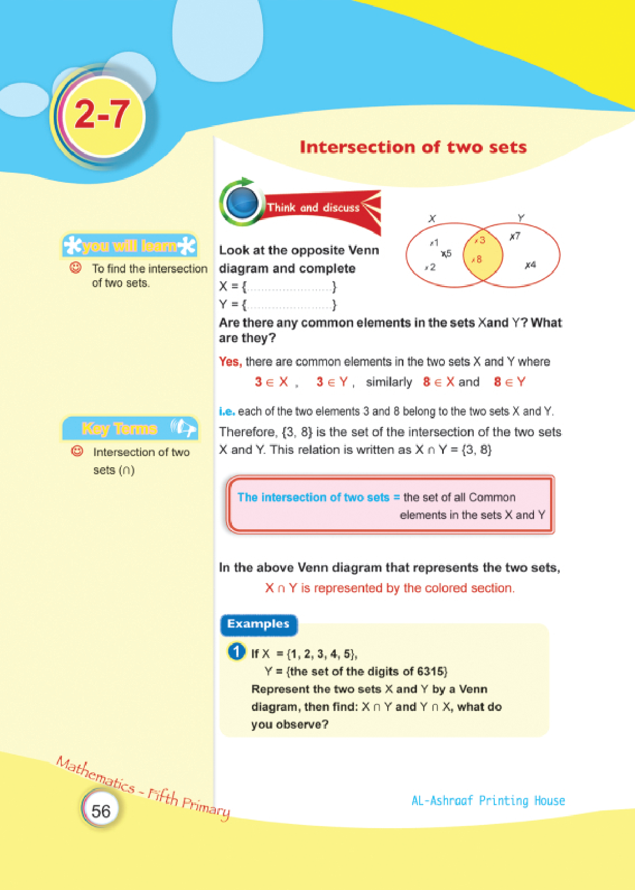
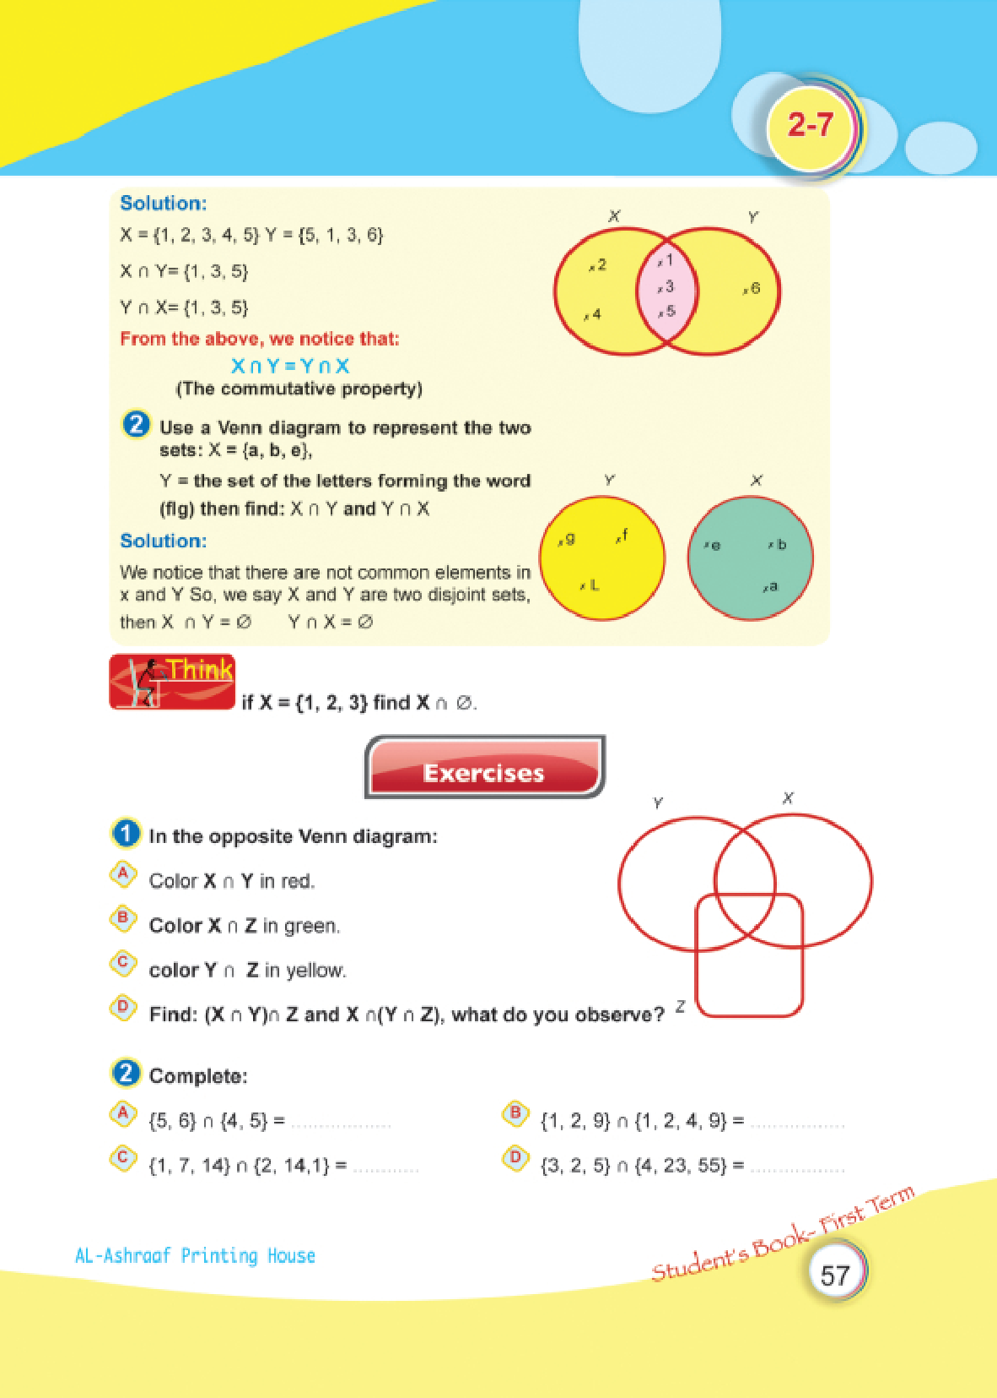
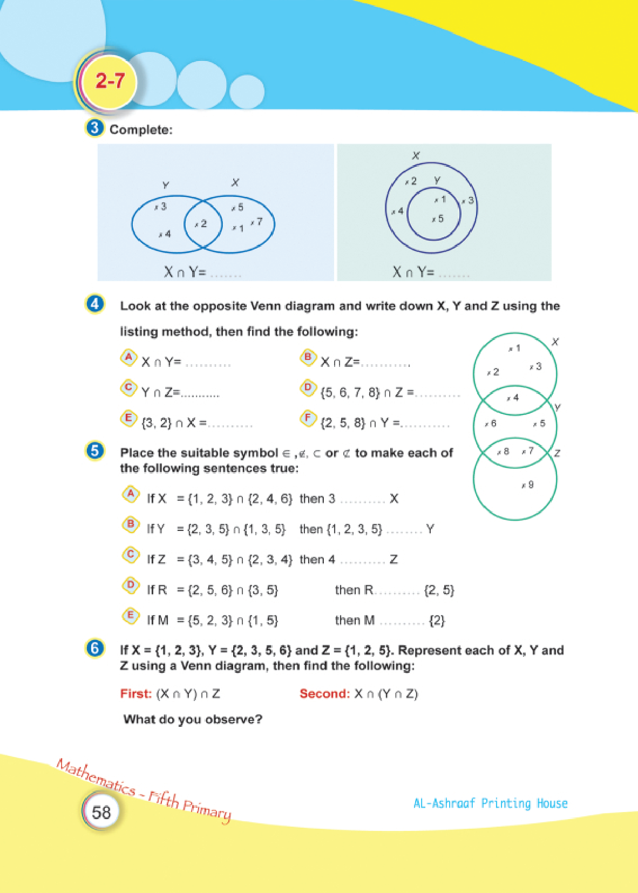

Lesson Eight: Union of two sets
# Source: Academic source: Provided by: [Data Path: Persons Table -> ID Column: 1, Name_En Column: Motasem Essam] -> From: [Data Path: Sources Table -> ID Column: 351, Content Title Column: Math - Fifth Primary - First Semester] -> at: [Document, page: 66:67] on [7/7/2026]
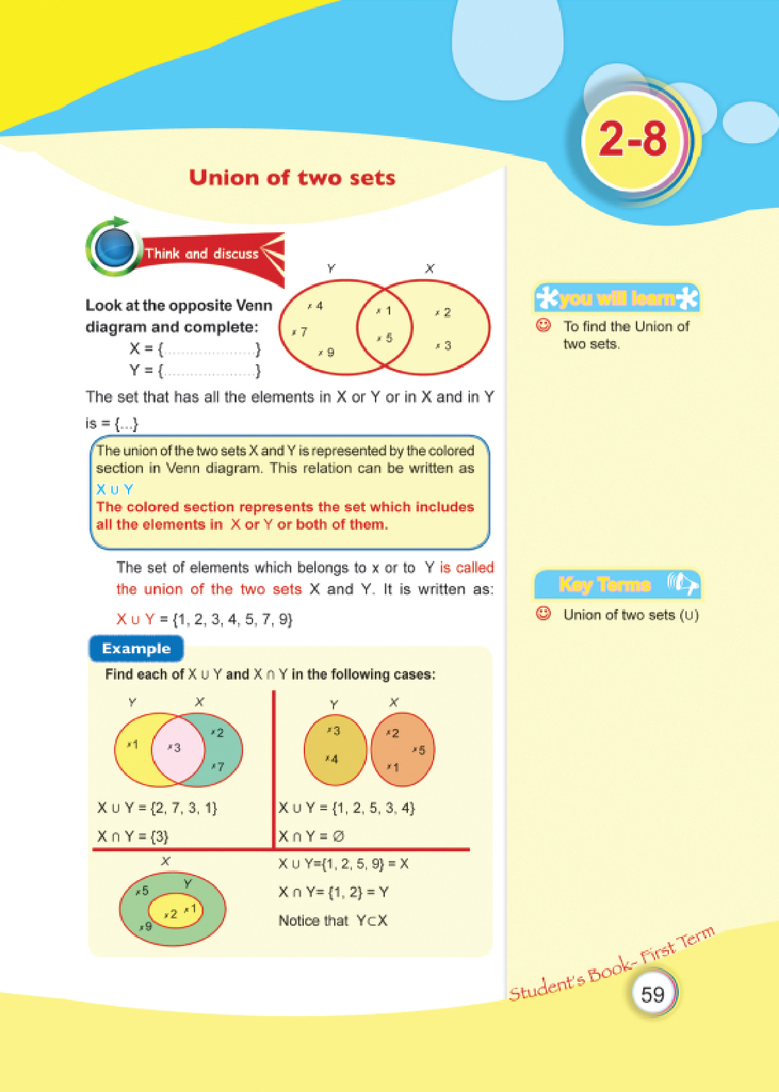
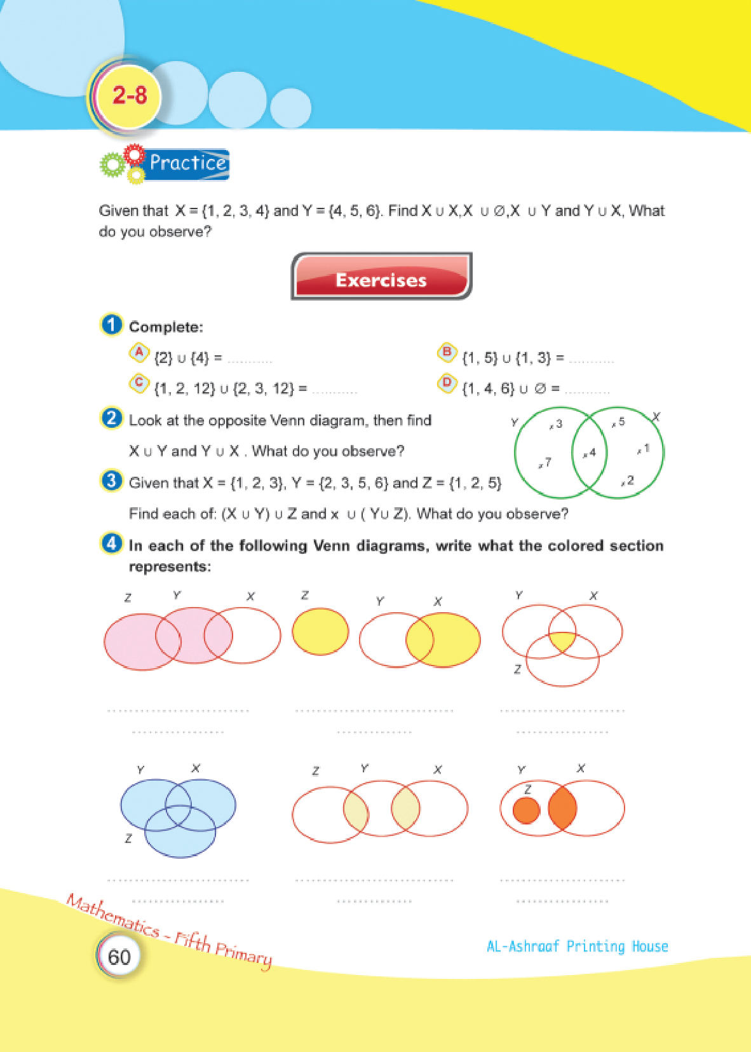

Lesson Ten: The complement Of a Set
# Source: Academic source: Provided by: [Data Path: Persons Table -> ID Column: 1, Name_En Column: Motasem Essam] -> From: [Data Path: Sources Table -> ID Column: 351, Content Title Column: Math - Fifth Primary - First Semester] -> at: [Document, page: 70:71] on [7/7/2026]
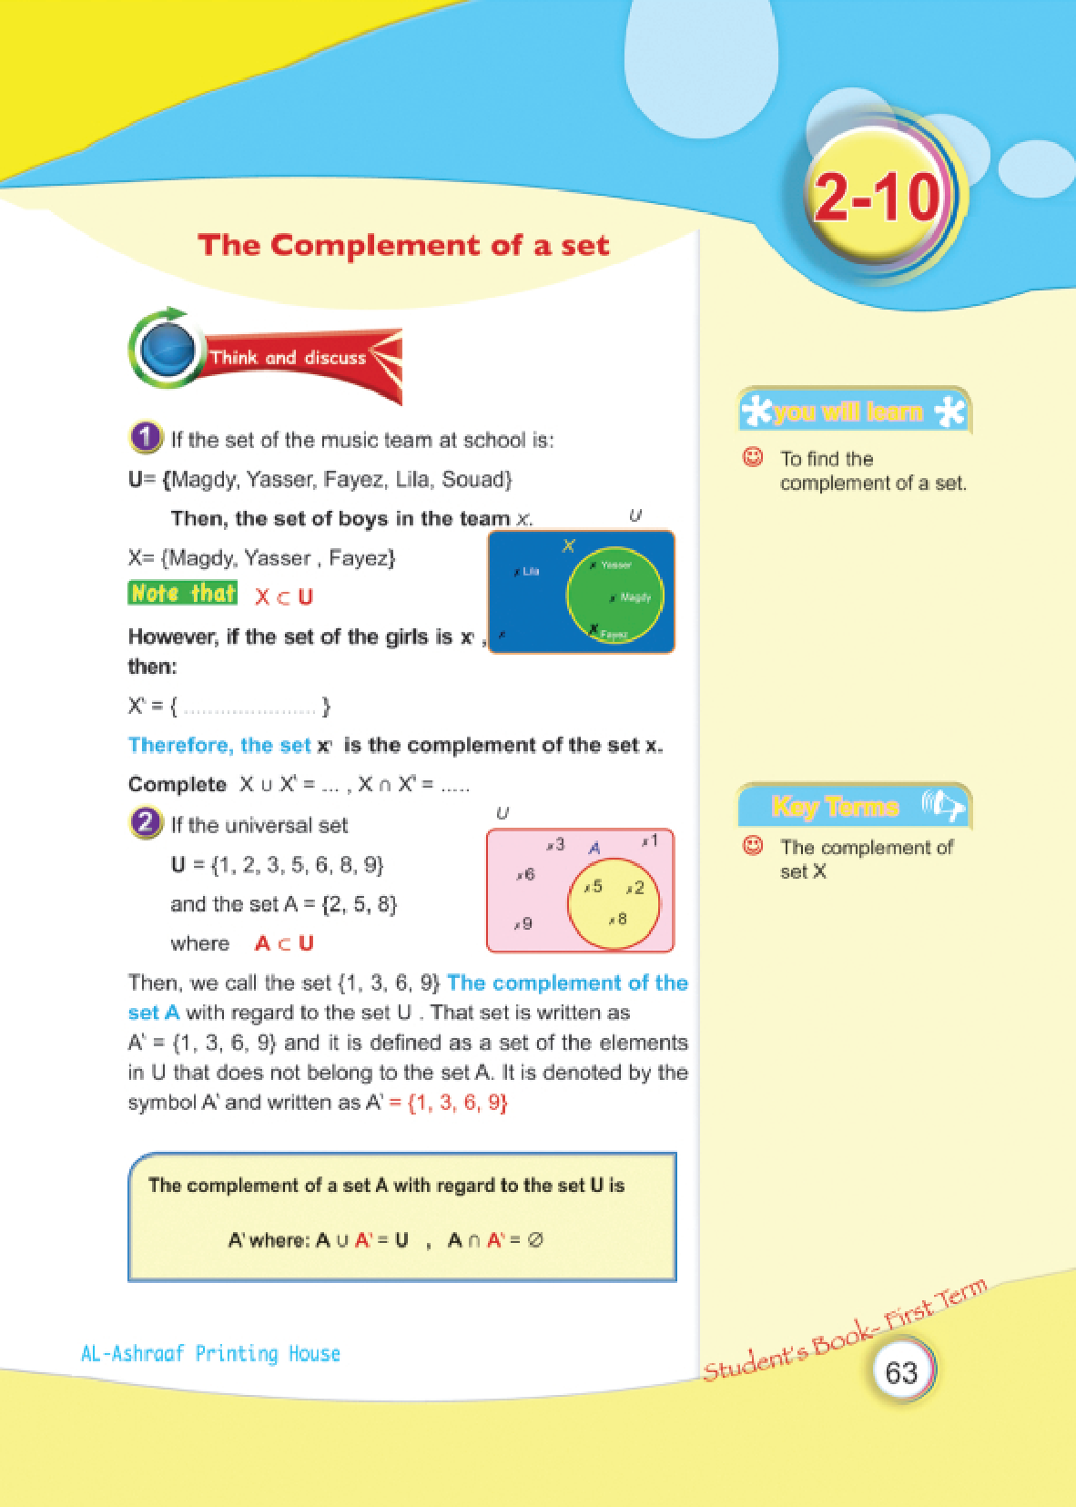
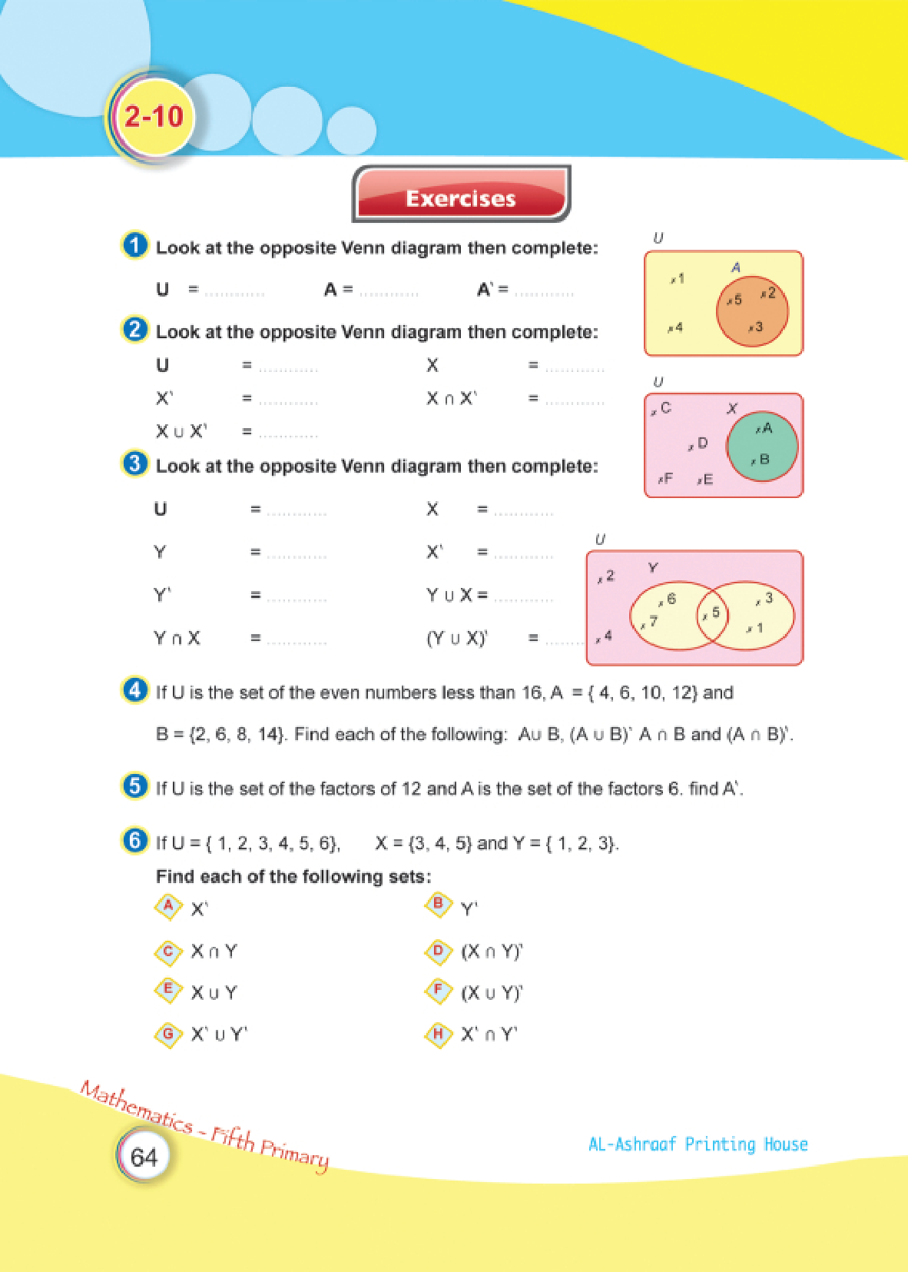

Lesson Eleven: The difference of two sets
# Source: Academic source: Provided by: [Data Path: Persons Table -> ID Column: 1, Name_En Column: Motasem Essam] -> From: [Data Path: Sources Table -> ID Column: 351, Content Title Column: Math - Fifth Primary - First Semester] -> at: [Document, page: 72:73] on [7/7/2026]


